**program 1 : Implement a client and server communication using sockets programming**

#include<sys/types.h>

#include<sys/socket.h>

#include<netinet/in.h>

#include<sys/stat.h>

#include<unistd.h>

#include<stdlib.h>

#include<stdio.h>

#include<fcntl.h>

#include <arpa/inet.h>

int main()

{

int cont,create_socket,new_socket,addrlen,fd;

int bufsize = 1024;

char *buffer = malloc(bufsize);

char fname[256];

struct sockaddr_in address;

if ((create_socket = socket(AF_INET,SOCK_STREAM,0)) > 0)

printf("The socket was created\n");

address.sin_family = AF_INET;

address.sin_addr.s_addr = INADDR_ANY;

address.sin_port = htons(15000);

if (bind(create_socket,(struct sockaddr *)&address,sizeof(address)) == 0)

printf("Binding Socket\n");

listen(create_socket,3);

addrlen = sizeof(struct sockaddr_in);

new_socket = accept(create_socket,(struct sockaddr *)&address,&addrlen);

if (new_socket > 0)

printf("The Client %s is Connected...\n ", inet_ntoa(address.sin_addr));

recv(new_socket,fname, 255,0);

printf("A request for filename %s Received..\n", fname);

if ((fd=open(fname, O_RDONLY))<0)

{

perror("File Open Failed"); exit(0);}

while((cont=read(fd, buffer, bufsize))>0) {

send(new_socket,buffer,cont,0);

}

printf("Request Completed\n");

close(new_socket);

return close(create_socket);

}

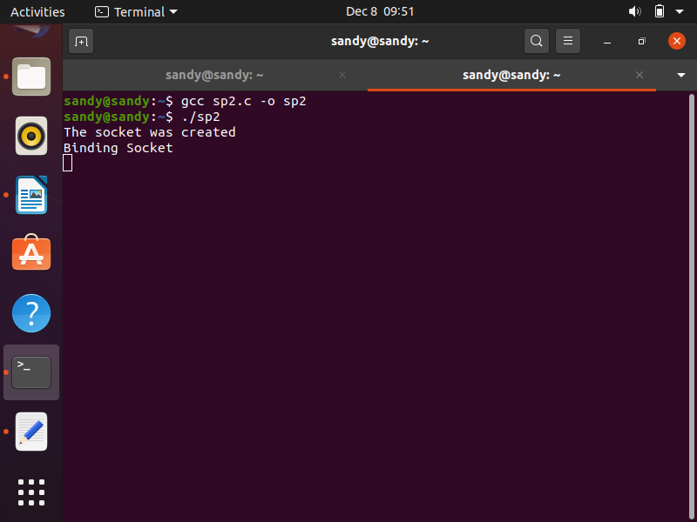

**client program :**

/* touch cp2.c -== to create c file */

/* compile == gcc cp2.c -o c */

#include<sys/socket.h>

#include<sys/types.h>

#include<netinet/in.h>

#include<unistd.h>

#include<stdlib.h>

#include<stdio.h>

#include <arpa/inet.h>

int main(int argc,char *argv[ ])

{

int create_socket;

int bufsize = 1024;

char *buffer = malloc(bufsize);

char fname[256];

struct sockaddr_in address;

if ((create_socket = socket(AF_INET,SOCK_STREAM,0)) > 0)

printf("The Socket was created\n");

address.sin_family = AF_INET;

address.sin_port = htons(15000);

inet_pton(AF_INET,argv[1],&address.sin_addr);

if (connect(create_socket,(struct sockaddr *) &address, sizeof(address)) == 0)

printf("The connection was accepted with the server %s...\n",argv[1]);

printf("Enter The Filename to Request : ");

scanf("%s",fname);

send(create_socket, fname, sizeof(fname), 0);

printf("Request Accepted... Receiving File...\n\n");

printf("The contents of file are...\n\n");

int cont;

while((cont=recv(create_socket, buffer, bufsize, 0))>0) {

write(1, buffer, cont);

}

printf("\nEOF\n");

return close(create_socket);

}

**OUTPUT**

input file is : myfile.txt

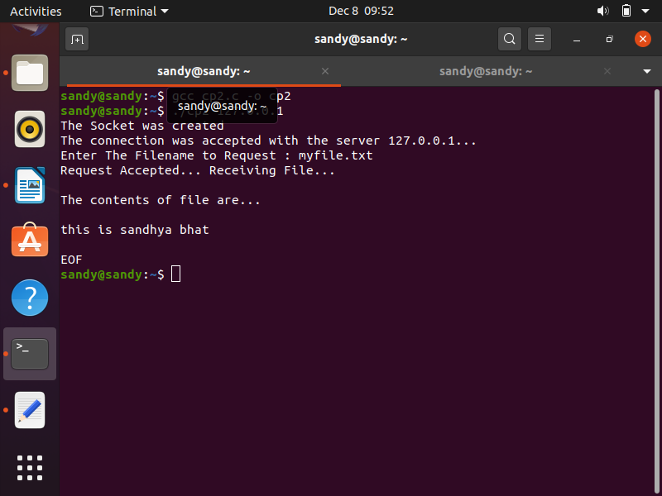

after execution , the server tab looks like:

